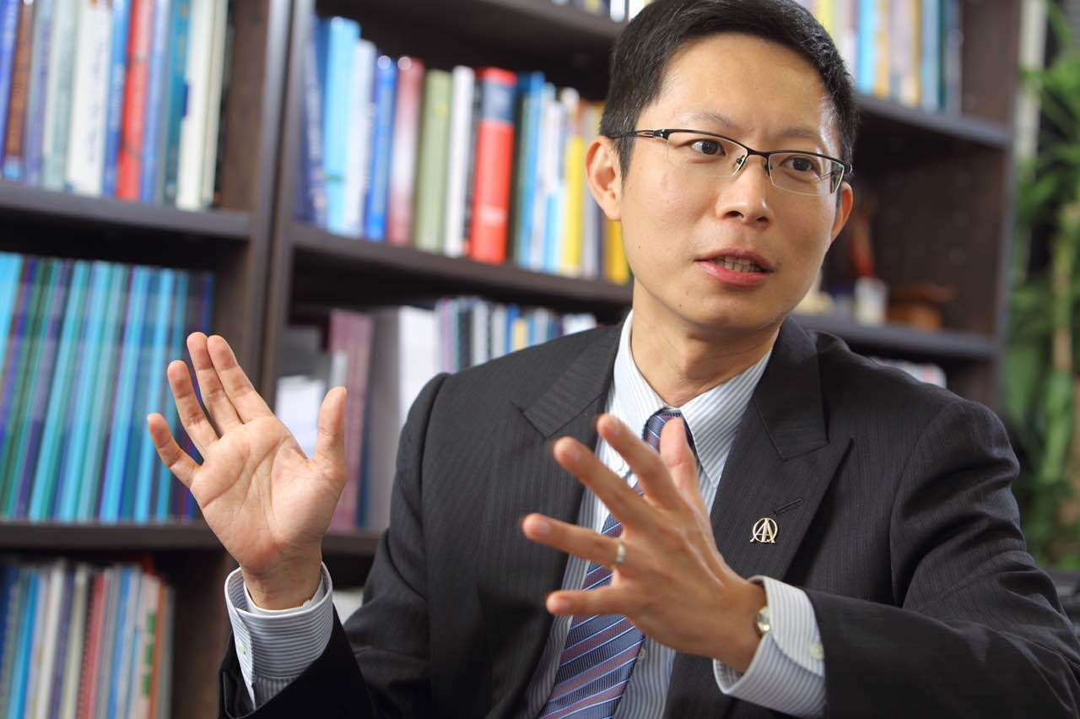
题 目：Quality Engineering faces the challenges of big data and little data.
质量工程面对大数据和小数据的挑战

报告人：宗福季教授
香港科技大学工业工程与物流管理系教授及质量实验室主任

时 间：2016年10月20日（星期四） 9:00-11:00

地 点：江宁校区经管学院办公楼704室

讲座内容：
This talk will present and discuss the challenges and opportunities that quality engineers face in the era of big data. The ability to separate signal and noise in the data-rich-information-poor environment would be the key, especially for industrial big data. Emerging issues include statistical process control and monitoring for big data streams, and reliability and maintenance modeling with big data.
The second part of the talk will present and discuss the challenges and opportunities that quality engineers face in the era of additive manufacturing (i.e., 3D printing), where there is little data due to its one-of-a-kind nature. For example, quality control techniques originated from mass production cannot be applied directly to such a highly customized/personalized environment because such a small or single lot production does not have repeated measures of the same kind.
报告人简介：
宗福季教授现任香港科技大学工业工程与物流管理系教授及质量实验室主任，美国工业工程师学会(IIE)会士，美国质量学会(ASQ)会士，国际质量学院(IAQ)院士，国际统计协会(ISI)當選会员，香港工程师学会 (HKIE)会士。任职科大后，他积极参与有关质量改善和管理的教育及研究工作。宗教授目前是美國质量学会旗艦期刊 Journal of Quality Technology (JQT) 的主編, 工业工程学会期刊 IIE Transactions 及 Technometrics 的副编辑。 宗教授于国立台湾大学取得机械工程学士学位，其后于美国密歇根大学获工业工程硕士及博士学位。

主办单位：经济与管理学院工业工程研究所

