**Brain Circulation: International Migration and Global Talent Management**

Tony Fang, PhD

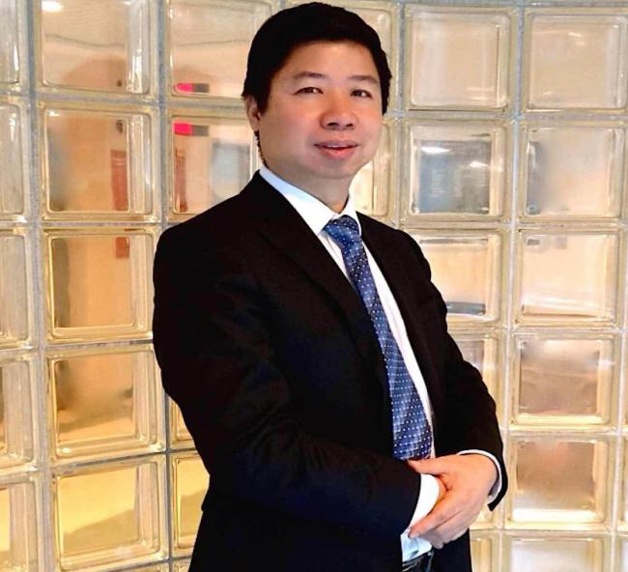

Stephen Jarislowsky Chair in Economic and Cultural Transformation, Memorial University

Adjunct Professor, University of Toronto, Canada

J. Robert Beyster Fellow, Rutgers University, USA

Past President, Chinese Economists Society

**Abstract**

This paper first reviews the recent trends in global migration and Canadian immigration policy since Canada adopted the “point system” in 1967, its relative strength, weakness, and success stories. It further examines whether and to what extent immigrant integration benefits the national economy by using a macroeconomic model. Then the paper will make a strong case that both the host country and home country can potentially benefit from international migration, especially when the economic and industrial structures are complementary between the two countries, for instance, Canada and China. Although China has been long considered as net exporter of talents, the talent management landscape is quickly changing, especially after China’s entry into the WTO in 2001. China has since moved through stages of talent flow, from “brain drain”, to “brain gain”, to “brain circulations”, as it joined the international war for talent and introduced a number of ambitious talent attraction and development plans to bring home highly skilled and Western-trained talents, while at the same time accepting Chinese diaspora as a viable option for overseas depository and reservoirs for future talents. This paper will also explain the current state of transitions for global talent management practices in China, highlight the unique challenges that Chinese managers and foreign entrepreneurs are facing—in particular, the far-reaching effects of Chinese culture on the talent management practices as well as future opportunities for China and beyond.

**Short Bio**

Tony Fang is the Stephen Jarislowsky Chair in Economic and Cultural Transformation at Memorial University of Newfoundland and an adjunct Professor with the University of. Currently he holds the J. Robert Beyster Faculty Fellowship at Rutgers University and sits on a World Bank's Expert Advisory Committee on Migration and Development. Prior to joining Memorial, he was the Director of Master of International Business Program at Monash University in Melbourne, Australia. He served as the President of the Chinese Economists Society (2012-13) and the Domain Leader at CERIS, Ontario Metropolis Centre (2009-12). He was a visiting professor at Harvard University and NBER, Wharton School of the University of Pennsylvania, City University of Hong Kong, University of Macau, Tsinghua University, Fudan University, and Southwest University of Finance and Economics. In 2010, he received the title of “Chutian Scholar” of Hubei Province.

Professor Fang has a Ph.D. in Industrial Relations and Human Resource Management from the University of Toronto. His areas of research interest encompass issues of immigration, diversity, and cultural changes, high performance workplace practices, pension, retirement policy and the ageing workforce, minimum wages and youth employment, union impact on wages, innovation and firm growth, pay equity and employment equity. He has published in such journals as *Industrial and Labor Relations Review (Cornell), Industrial Relations (Berkeley), British Journal of Industrial Relations (LSE), Strategic Management Journal, International Journal of Human Resource Management, Canadian Journal of Economics, Canadian Public Policy, China Economic Review, Asian Economic Papers, Journal of World Business, Journal of Labor Research, IZA Journal of Labour Policy, International Journal of Manpower, Journal of Management History, Social Indictors Research, and Perspectives on Labour and Income*. He has also received 9 research awards from SSHRC and 5 research grants HRSDC, totaling $1.5 million. In 2015, he was appointed as the Jarislowsky Chair at Memorial University, with $2 million endowment support from the Jarislowsky Foundation, Government of Newfoundland and Labrador, and private donations.

方涛博士是纽芬兰纪念大学Stephen Jarislowsky讲席教授, 加拿大多伦多大学和澳大利亚莫纳什大学兼职教授，羅格斯大學J. Robert Beyster研究員, 世界银行“移民与发展”专家咨询委员会专家。他曾担任美国哈佛大学访问教授，沃顿商学院访问教授、约克大学人力资源管理与劳资关系终身教授。他是中国留美经济学会前任会长。同时他还是多伦多大学、香港城市大学、澳门大学、清华大学、复旦大学、西南财经大学以及中国地质大学的客座教授。2010年，他入选中国湖北省“楚天学者”。

方涛教授在多伦多大学取得劳资关系和人力资源管理专业博士学位。他在《战略管理杂志》、《加拿大经济杂志》、《中国经济评论》、《亚洲经济杂志》、《工业与劳动关系评论》(康奈尔)、《劳资关系》(伯克利)、《世界商务杂志》、《国际人力资源管理杂志》、加拿大公共政策》、英国《劳资关系杂志》(伦敦经济学院)、《劳动研究》、《IZA劳动政策杂志》、《国际人力杂志》、《管理史杂志》、《社会指标研究》以及《透视劳工及收入》等刊物均有发表。方涛博士在加拿大获得了社会人文科学委员会颁发的12项研究奖项和由人力资源管理与加拿大人力资源与技能开发部授予的5项研究拨款, 总数四百万加元。2015年获聘纽芬兰纪念大学Stephen Jarislowsky讲席教授，他接受了由Stephen Jarislowsky基金会和纽芬兰省政府及私人两百万加元的捐赠。

报告时间：2016年5月6日下午4:00-6:00

报告地点：经济与管理学院704

主办单位：南京航空航天大学人力资源管理研究所、技术创新研究所