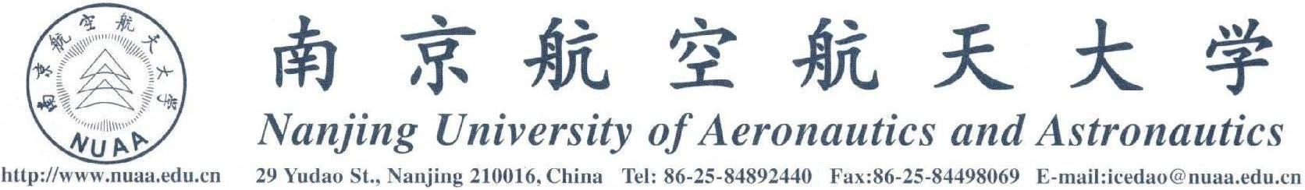

演讲人：雷震，化学和经济学双博士 Assistant Professor at Penn State University
演讲题目：Patent Subsidy and Patent Filings in China
时间：2014年10月28日（星期二）上午9：00
地点：南航将军路校区东区 D3107

附：雷震博士简介
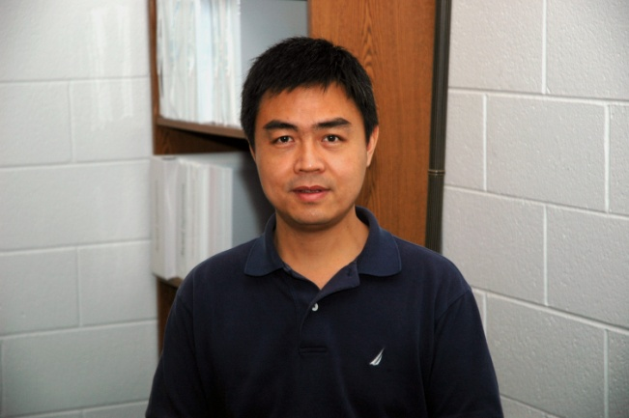
Zhen Lei is currently an Assistant Professor at Penn State University. He has expertise in both economics and the natural sciences, holding a Ph.D. degree in Economics and a Ph.D. degree in Chemistry. His research interests include technology and science and policy economics, economics of innovation, intellectual property policy and entrepreneurship, energy and environmental economics, big data and data mining, industrial organization, development economics, and applied econometrics.

Zhen Lei has published papers in top journals including Nature and Nature Biotechnology, and in premier data mining conferences. His research has been supported by research grants from the U.S. National Science Foundation (NSF), National Institutes of Health (NIH), Department of Energy (DOE), and U.S. Patent and Trademark Office (USPTO).

Ph.D. (Agricultural and Resource Economics), University of California at Berkeley, 2009
Ph.D. (Chemistry and Pharmaceutical Sciences), Peking University Health Sciences Center, 2000

M.S. (Organic Chemistry), Chinese Academy of Sciences, 1997
B.S. (Chemistry), Wuhan University, 1993

经济与管理学院 国际合作与交流处 创新与发展研究中心

