学术报告

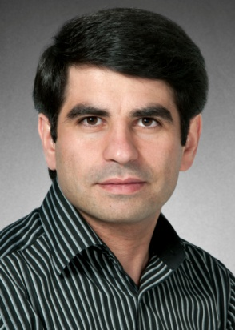**Data-Driven Analytics to Support Scheduling of Multi-Priority Multi-Class Patients with Wait Targets**

主讲人：Hossein Abouee Mehrizi教授, Department of Management Sciences, University of Waterloo, Ontario, Canada

时间地点：2016年10月10日3:00-4:00经管院704室

举办单位：南航经管学院智能决策与风险分析研究所

报告摘要：

The aim of dynamic scheduling is to efficiently assign available resources to the most suitable patients. The dynamic assignment of multi-class, multi-priority patients over time has long been a challenge, especially for scheduling in advance and under non-deterministic capacity. In this paper, we first conduct descriptive analytics on MRI data of over 3.7 million patient records from 74 hospitals. The dataset captures patients of four different priority levels, with different wait time targets, seeking treatment for one of ten classes of procedures, which have been scheduled over a period of 3 years. The goal is to serve 90% of patients within their wait time targets; however, under current practice, 67% of patients exceed their target wait times. We characterize the main factors affecting the waiting times and conduct predictive analytics to forecast the distribution of the daily patient arrivals, as well as the service capacity or number of procedures performed daily at each hospital. We then prescribe two simple and practical dynamic scheduling policies based on a balance between the First-In First-Out (FIFO) and strict priority policies; namely, weight accumulation and priority promotion. Under the weight accumulation policy, patients from different priority levels start with varying initial weights, which then accumulates as a linear function of their waiting time. Patients of higher weights are prioritized for treatment in each period. Under the priority promotion policy, a strict priority policy is applied to priority levels where patients are promoted to a higher priority level after waiting for a predetermined threshold of time. To evaluate the proposed policies, we design a simulation model that applies the proposed scheduling policies and evaluates them against two performance measures: 1) total exceeding time: the total number of days by which patients exceed their wait time target, and 2) overflow proportion: the percentage of patients within each priority group that exceed the wait time target. Using historical data, we show that, compared to the current practice, the proposed policies achieve a significant improvement in both performance measures. To investigate the value of information about the future demand, we schedule patients at different points of time from their day of arrival. The results show that hospitals can considerably enhance their wait time management by delaying patient scheduling.

Mehrizi教授简介：

